Below is an overview of key Java concurrency tools and concepts:

1. Semaphore
- Purpose: Controls access to a resource pool by maintaining a set number of permits.
- Key Features:
  - Threads acquire a permit before proceeding and release it after finishing.
  - Used to limit concurrent access to resources.
- Example:
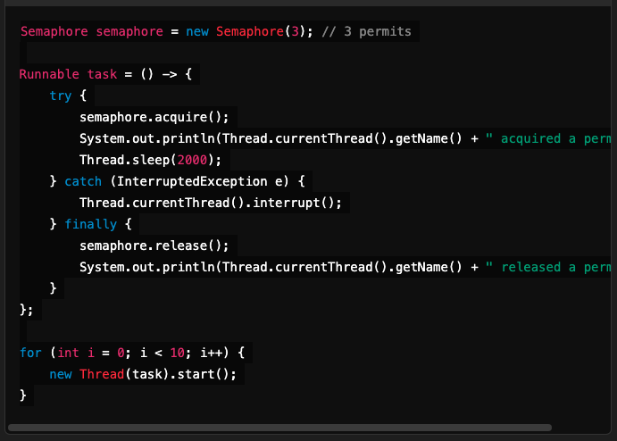

2. ThreadLocal
- Purpose: Provides thread-local variables, ensuring each thread has its own independent copy.
- Key Features:
  - Useful for storing per-thread data (e.g., user sessions or transactions).
- Example:
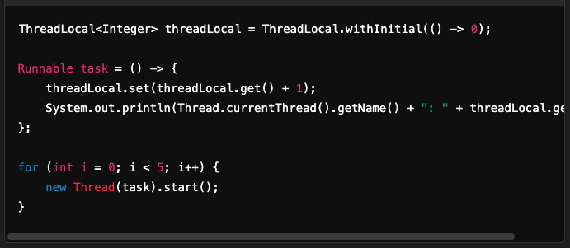

3. Fork and Join Framework
- Purpose: Splits tasks into smaller subtasks, executes them in parallel, and combines the results.
- Key Features:
  - Implements the divide and conquer approach.
  - Ideal for parallelizing recursive algorithms.
- Example:
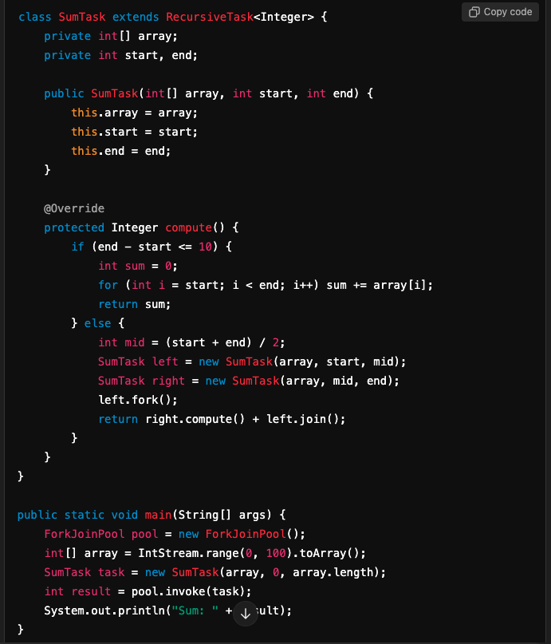

4. CountDownLatch
- Purpose: Allows one or more threads to wait until a set of operations in other threads are completed.
- Key Features:
  - The latch is initialized with a count that decreases as threads call countDown.
  - Threads waiting on await are released when the count reaches zero.
- Example:
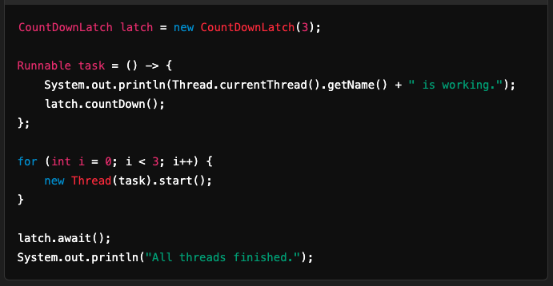

5. Mutex
- Purpose: A mutual exclusion lock to ensure only one thread accesses a critical section at a time.
- Example: Typically implemented with ReentrantLock or synchronized.

6. LockSupport.park
- Purpose: A low-level tool to block (park) or unblock (unpark) threads.
- Key Features:
  - Does not require explicit locks.
- Example:
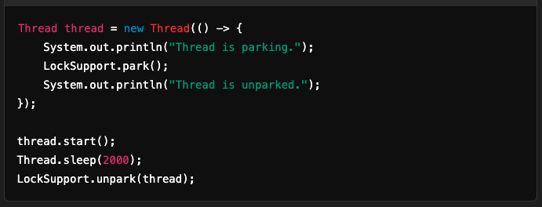

7. Phaser
- Purpose: A flexible synchronization barrier, allowing threads to coordinate phases of execution.
- Key Features:
  - Supports dynamic thread registration and deregistration.
- Example:
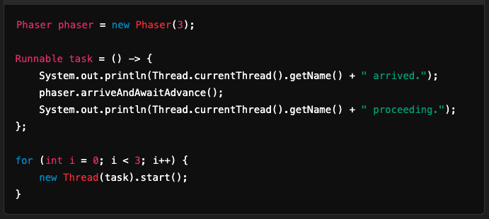

8. Fair Lock
- Purpose: Ensures threads acquire locks in the order they requested.
- Example:
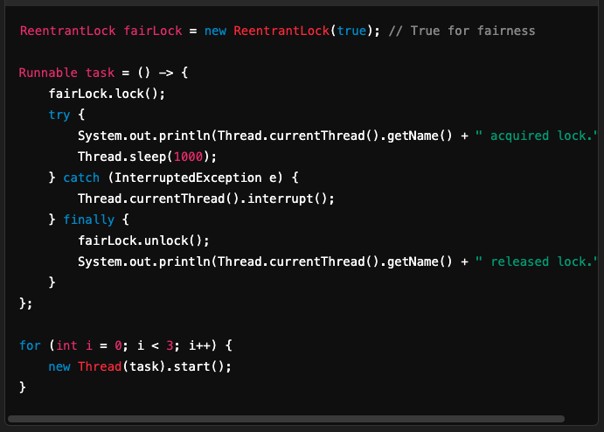

9. RateLimiter
- Purpose: Controls the rate at which threads or tasks acquire permits.
- Key Features:
  - Useful for throttling API calls or processing.
- Example:
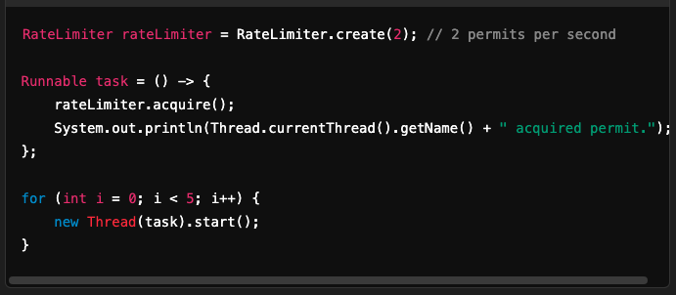

These tools provide powerful mechanisms to manage concurrency in Java.

